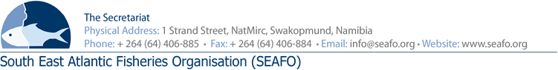
PROVISIONAL AGENDA FOR THE 10TH STANDING COMMITTEE ON ADMINISTRATION AND FINANCE (SCAF) MEETING - 2018

CHAIR: Mr. Takahiro Ara (Japan 2018-2019) Venue: Strand Hotel, Swakopmund
VICE-CHAIR: To be Confirmed (South Korea 2018-2019) Date: 28 November 2018

 | Agenda Item | Working Document
1 | Opening of Meeting by Chairperson
2 | Appointment of Rapporteur
3 | Adoption of the Agenda and Meeting Arrangements | DOC/SCAF/00/2018  DOC/SCAF/01/2018  DOC/SCAF/02/2018
4 | Introduction of Delegations
5 | Presentation of the 2017 Audit Report | DOC/SCAF/03/2018  DOC/SCAF/04/2018
6 | Presentation of the Executive Secretary Report on Administration and Finance | DOC/SCAF/05/2018
7 | Approval of the2019 Provisional and 2020 forecast Budgets | DOC/SCAF/06/2018  DOC/SCAF/07/2018  DOC/SCAF/08/2018  DOC/SCAF/09/2018  DOC/SCAF/10/2018
8 | Contribution by Contracting Parties
9 | Any other Matters | DOC/SCAF/11/2018  DOC/SCAF/12/2018  DOC/SCAF/13/2018
10 | Venue and date of next meeting
11 | Adoption of the SCAF report
112 | Closure of Meeting

Circulation Date: 28 October 2018 SEAFO Website

